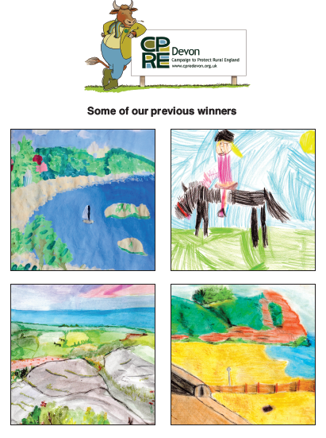
CPRE Devon (Campaign to Protect Rural England) are running an art and writing competition to encourage children to appreciate their local countryside. The competition will run until 30th June with prizes awarded in 2 age categories- Reception or KS1 & KS2. All entrants will receive a CPRE Devon ‘Barney the bull’ gift. Winning schools will receive £200 to spend on outdoor learning.
- Art competition: Draw or paint your local environment or favourite outdoor space such as your school grounds, your local town or village, your garden, a park, playground, green space nearby...
- Writing competition: Think about and explain why, by completing the sentence- “I think it’s important to protect Devon’s countryside because...”
Take a photograph of your entry and email: info@cpredevon.org.uk and include the name of the school, head teacher, year group, class teacher, school address, your phone number and email address. Or post your entry to: Penny Mills, CPRE Devon, PO Box 26, Beaworthy, Devon. EX21 5XN.

The Messy Magpie free ebook (for use on computers or laptops):
https://www.twinkl.co.uk/resource/t-l-54501-the-messy-magpie-ebook
The Messy Magpie story read on YouTube (for use on anything):
https://www.youtube.com/watch?v=GvOhu2mLKsw

