
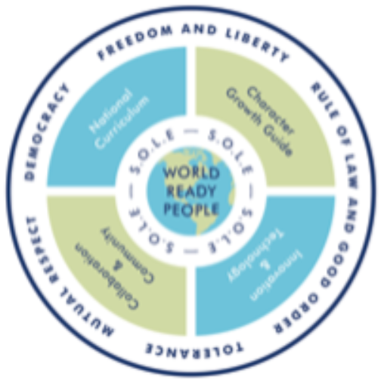
Honiton Primary School
Whole School Project Overview 2022/2023 [RSE Curriculum]

Year Group | Project 1 | Project 2 | Project 3 | Project 4 | Project 5/6
1 | Wonderful Woods  How can we look after each other and the world? | Jurassic World  Who is special to us? | Explorers  What can we do with money? | Heroes  Who helps us to stay safe? | Brilliant Brazil  What is the same and what is different about us? | Wild Weather  What helps us to stay safe?
2 | Wondrous Wildlife  What makes a good friend? | Kings and Queens  What is bullying? | Shiver Me Timbers  What helps us grow and stay safe? | (Oh I do like to be) Beside The Seaside  What jobs do people do? | Flower Power  How do we recognise our feelings? [Summer1]  What helps us stay safe? [Summer2]
3 | Cautious Creatures  How can we be a good friend? | Time Travellers  What are families like? | Natural Disasters  What helps us keep safe? | Magnificent Metals  Why should we eat well and look after our teeth? | The Greeks  Why should we keep active and sleep well?[Summer1]  What makes a community?[Summer2]
4 | Marvellous Mixtures  How can we manage risk in different situations? | Roman Warriors  What strengths, skills and interests do we have? | Ocean Explorers  How can our choices make a difference to others and the environment? | Across the Continents  How can we manage our feelings? | Digestion Detectives  How will we change and grow?[Summer1]  How do we treat each other with respect?[Summer2]
5 | Mighty Mechanisms  What jobs would we like? | Torturous Tudors  How can friends communicate safely? | Space Exploration  What decisions can people make with money? | Ancient Egypt  How can we help in an accident or emergency? | Life Cycles  How can drugs common to everyday life affect health? [Summer1]  What makes up a person’s personality? [Summer2]
6 | Healthy Heart  How can we keep healthy as we grow? | World War Two  How can the media influence us? | Darwin’s Discoveries  How can the media influence us? | Pole to Pole  How can we keep healthy as we grow? | The Victorians  What will change as we become more independent? [Summer1]  How do friendships change as we grow? [Summer2]

RSE Question Strands: Living In the Wider World Relationships Health & Wellbeing

