How To Keep Hydrated And Strong In Your Class.

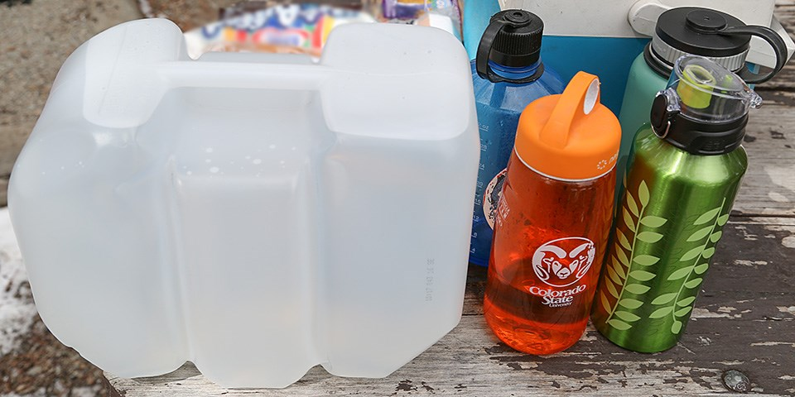
Keeping hydrated and strong is essential for you and our lives.here is 5 top tips for staying hydrated.it...

- Promotes weight loss
- Flushes out toxins
- Improves skin
And it maintains regularity with people.

When staying hydrated you feel more awake and agile.here’s a before.

__before_________

You see people are less active when they are dehydrated but active when hydrated.so keep drinking water.

